**Project Development Phase Model Performance Test**

|  |  |
| --- | --- |
| Date | 9 November 2023 |
| Team ID | EXT2023TMID 591061 |
| Project Name | Wanderlust-A Personalized Travel Planning and Tracking App |
| Maximum Marks | 10 Marks |

**Model Performance Testing:**

**8.1 Performance Metrics**

Performance testing for an Android app involves evaluating its responsiveness, speed, stability, and scalability under various conditions. This type of testing is crucial to ensure that the app performs well and provides a positive user experience across different devices and network conditions. Here are some key aspects of performance testing for an Android app:

**Load Testing:**

**Purpose:** Evaluate how well the app performs under expected and peak loads.

**Activities:**

-Simulate multiple users interacting with the app simultaneously.

-Measure response times and resource usage under varying levels of load.

**Stress Testing:**

**Purpose:** Determine the app's behavior under extreme conditions.

**Activities:**

Push the app beyond its normal capacity to identify breaking points.

Monitor how the app recovers from high-stress scenarios.

**Responsiveness Testing:**

**Purpose:** Assess the app's responsiveness to user interactions.

**Activities:**

Measure the time it takes for the app to respond to user inputs.

Evaluate the smoothness of animations and transitions.

**Network Performance Testing:**

**Purpose:** Evaluate how the app performs under different network conditions.

**Activities:**

Test the app on various network speeds (3G, 4G, Wi-Fi) to ensure optimal performance.

Check how the app handles network interruptions and reconnects.

**Memory Usage Testing:**

**Purpose:** Identify memory leaks and ensure efficient memory management.

**Activities:**

**Monitor the app's memory usage during different tasks.**

Check for memory leaks that could lead to performance degradation over time.

**Battery Consumption Testing:**

**Purpose:** Assess the impact of the app on the device's battery life.

**Activities:**

Measure power consumption during various app activities.

Identify and optimize power-intensive operations.

**Compatibility Testing:**

**Purpose:** Ensure the app performs consistently across different Android versions and devices.

**Activities:**

Test the app on a range of Android devices with different specifications.

Verify compatibility with different screen sizes and resolutions.

**Scalability Testing:**

**Purpose:** Evaluate how well the app scales with increased user load or data.

**Activities:**

Test the app's performance with a growing user base or dataset.

Identify and address any performance bottlenecks.

**Installation and Launch Time Testing:**

**Purpose:** Assess the time it takes to install and launch the app.

**Activities:**

Measure installation time on different devices.

Evaluate the time it takes for the app to become usable after launch.

**Offline Mode Testing:**

**Purpose:** Evaluate how the app performs when offline or with limited connectivity.

**Activities:**

Test functionality in offline mode.

Verify that the app gracefully handles scenarios with intermittent or no connectivity.

Performance testing should be an integral part of the app development life cycle to ensure a smooth and efficient user experience across a variety of real-world conditions.

***Performance Testing for Wanderlust Travel Planning App:***

**-Responsiveness:** Evaluate how quickly the app responds to user actions, such as searching for flights, hotels, or activities.

**-Stability:** Test the app's stability under different conditions, like low network connectivity or high server loads.

**-Load Testing:** Assess how well the app performs under heavy user loads, simulating peak usage scenarios.

**-Scalability:** Check how well the app scales as the number of users or data increases.

**-Usability:** Assess the user experience and interface for ease of use and clarity.

Project team shall fill the following information in model performance testing template.

|  |  |  |  |
| --- | --- | --- | --- |
| **S.No** | **Parameter** | **Values** | **Screenshot** |
| 1. | Model Summary | **Total params: 19,06,928**  **Trainable params: 19,06,928**  **Non-trainable params: 0** |  |
| 2. | Accuracy | Training Accuracy - 91.34  Validation Accuracy - 93.06 |  |
| 3. | Confidence Score (Only Yolo Projects) | Class Detected - NA  Confidence Score - NA | Not Applicable |

**Screenshot:**

**Model Summary**

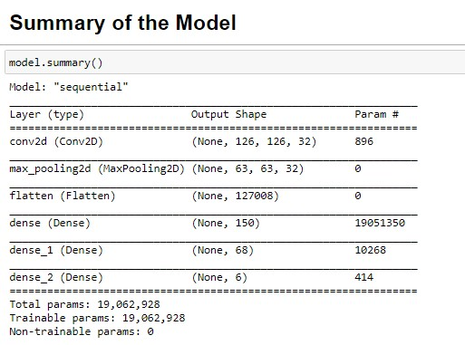

**Accuracy**

